MCPIKE MANSION TOURS And EVENTS 2022
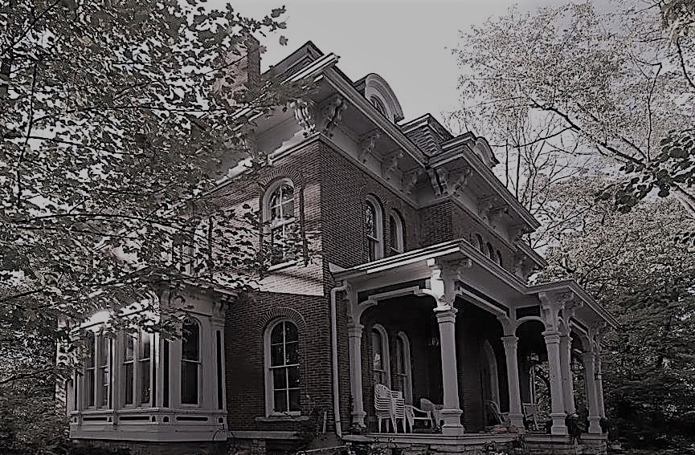
To register for an event or tour and details visit the website http://www.mcpikemansion.com
Help preserve the history of McPike Mansion – 2018 ALBY St. Alton, Illinois
Email sluedke14@gmail.com Or call Sharyn Luedke cell 618 830 2179
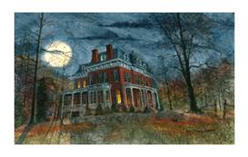
2022 TOURS: Tours – Adults $20/Teens $10 / Child $5
Attendees limited to 35 per tour due to Covid 19. Please Pre-register on the website.
A mask and social distancing is required while at the tour.

Sat April 30th 7pm – Honoring Mother Earth tour
Sat May 21st 7pm – Armed Forces Tour
Sat June 11th 7pm – Flag Day Tour
Sat July 16th 7pm – Happy Birthday Henry – Birthday on the lawn tour
Sat Aug 20th 7pm – Back to school Tour
Sat Sept 10th 7pm – Welcoming the Fall tour

OCTOBER TOURS – a Tour every weekend
Friday – Sept 30th 7:30pm – Welcoming the Halloween Season Tour
Saturday- October 1st 7:30pm – Hob-knobbing with the Spirits tour
Friday – October 7th 7:30pm – Freaky Friday tour
Saturday – October 8th 7:30pm– Chills and Thrills Tour
Friday-October 14th 7:30pm – Black Cat Crossing Tour
Saturday – October 15th 7:30pm – Gabbing with the Ghosts tour
Friday – October 21st 7:30pm – Ghoul Tour
Saturday – October 22nd 7:30pm – Fright Night Tour
Friday – October 28th 7:30pm – Ghost Bustin Tour
Saturday – October 29th 7:30pm – Last Chance Tour

Tours include - history and stories of McPike, tour of the grounds, Dark Session in the Cellar with Medium “Sandy Little Lizard”.

