MCPIKE MANSION TOURS And EVENTS 2020
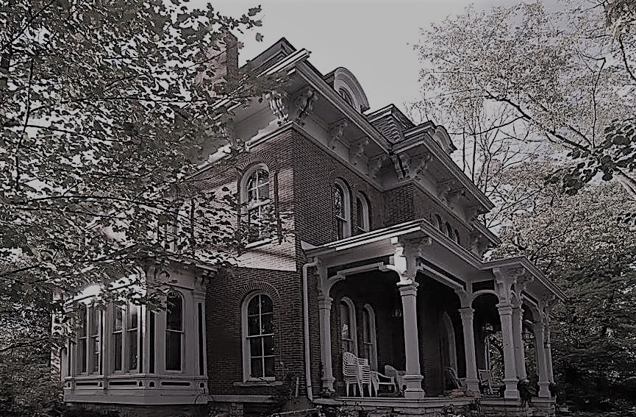
To register for an event or tour and details visit the website http://www.mcpikemansion.com
Help preserve the history of McPike Mansion – 2018 ALBY St. Alton, Illinois
Email sluedke@charter.net Or call Sharyn Luedke cell 618 830 2179
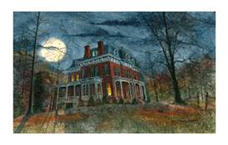
2020 TOURS: Tours – Adults $20/Teens $10 / Child $5
Sat April 25th 7pm – Honoring Mother Earth tour
Sat May 16th 7pm – Armed Forces Tour
Sat June 13th 7pm – Flag Day Tour
Sat July 11th 7pm – Happy Birthday Henry – Birthday on the lawn tour
Sat Aug 8th 7pm – End of Summer tour
Sat Sept 26th 7pm – Welcoming the Halloween Season tour

OCTOBER TOURS – a Tour every weekend
Friday – October 2nd 7pm – Fright Night tour
Saturday- October 3rd 7pm – Hob-knobbing with the Spirits tour
Friday – October 9th 7pm – Freaky Friday tour
Saturday – October 10th 7pm– Chills and Thrills Tour
Friday-October 16th 7pm – Black Cat Crossing Tour
Saturday – October 17th 7pm – Gabbing with the Ghosts tour
Friday – October 23rd 7pm – Ghoul Tour
HALLOWEEN CAMPOUT Oct 24th / 25th 18 or older – NO ALCOHOL $30
Friday – October 30th 9pm – Ghost Bustin Tour
Sunday – Nov 1st 6pm – Last Chance Tour

Tours include - history and stories of McPike, tour of the grounds, Dark Session in the Cellar with Medium “Sandy Little Lizard”.

